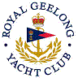 | Royal Geelong Yacht Club Inc.  Est 1859
Trophy Deed of Gift.

Trophy: | Taleisin Trophy
Presented by: | TBA
Date: | 2012
For: | Wooden Boat Festival Best Dressed Boat under 30 feet
Remarks / Revisions
Click here for a List of Recipients
